 **INFRAMIND SEASON -4**



**USE CASE**

|  |  |  |
| --- | --- | --- |
| Name | CT Number | E-Mail ID |
| Praveen kumar S | CT20182439395 | spraveenjayan@gmail.com |

**SUSTAINABILITY AND WELLNESS**



Github Link



Video Presentation Link



**CONTENTS**

1. Introduction

2. Problem Statement

3. Understanding Problem Statement

4. Solution Identification

5. Details of Technology used

6. Software and Hardware required

7. Solution Brief Description

8. Overall Workflow

9. Technical Workflow

10. Pros

11. Application Interface

12. Conclusion



**Introduction:**

An electronic device that can be worn as accessories. The devices are hands-free gadgets with practical uses, powered by microprocessors and enhanced with the ability to send and receive data via the Internet.

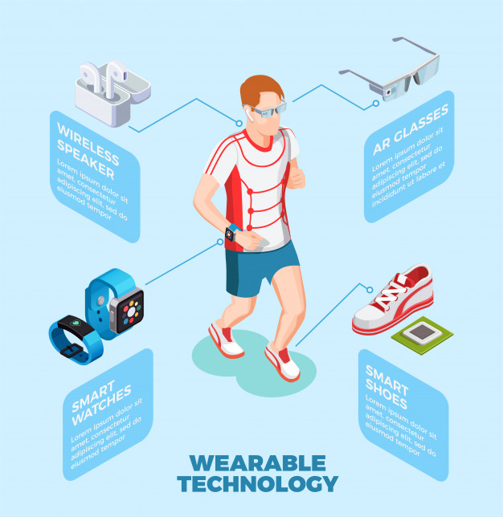



**Problem Statement:**

A Company XYZ has 100 employees working where it has provided each and every employee with an android support wearable technology to monitor each and every one’s health. The company’s major concern is the priority of the employee’s health. Now they have to fulfil the second half of their target which would be creating an application to monitor individually and to govern them as a group.

**Understanding Problem Statement:**

The problem statement provides two tasks.

1. Create an application to monitor the employee’s individually and to govern them as group.
2. To predict and inform the employee as well as the company about the precautions to be taken beforehand.

**Solution Identification:**

To achieve the desired results,

1. Create a mobile application to track the health of the employee and from the wearable technology

update their health parameters in the cloud for every 30 seconds.

1. Create a web application to track and maintain all the employee’s health information using database.



**Details of Technology Used:**

**Cloud Server:**

**Cloud** offers the possibility of storing, accessing, retrieving our files from any web-enabled interface. IoT clouds are efficient, flexible, and scalable.

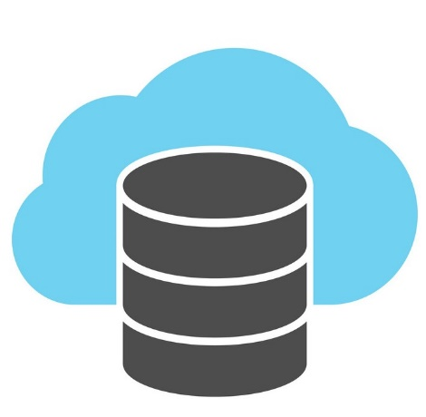

**Internet of Things:**

The **Internet of things** (**IoT**) are embedded with sensors, software, and other technologies for the purpose of connecting and exchanging data with other devices and systems over the Internet.

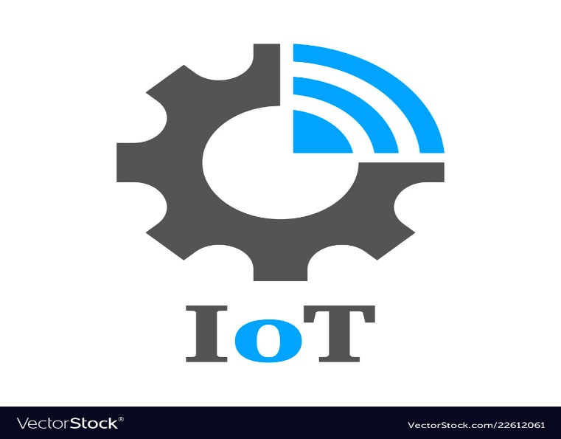

**Machine Learning:**

Machine learning uses past behaviour to identify patterns and builds models that help predict future behaviour and events.

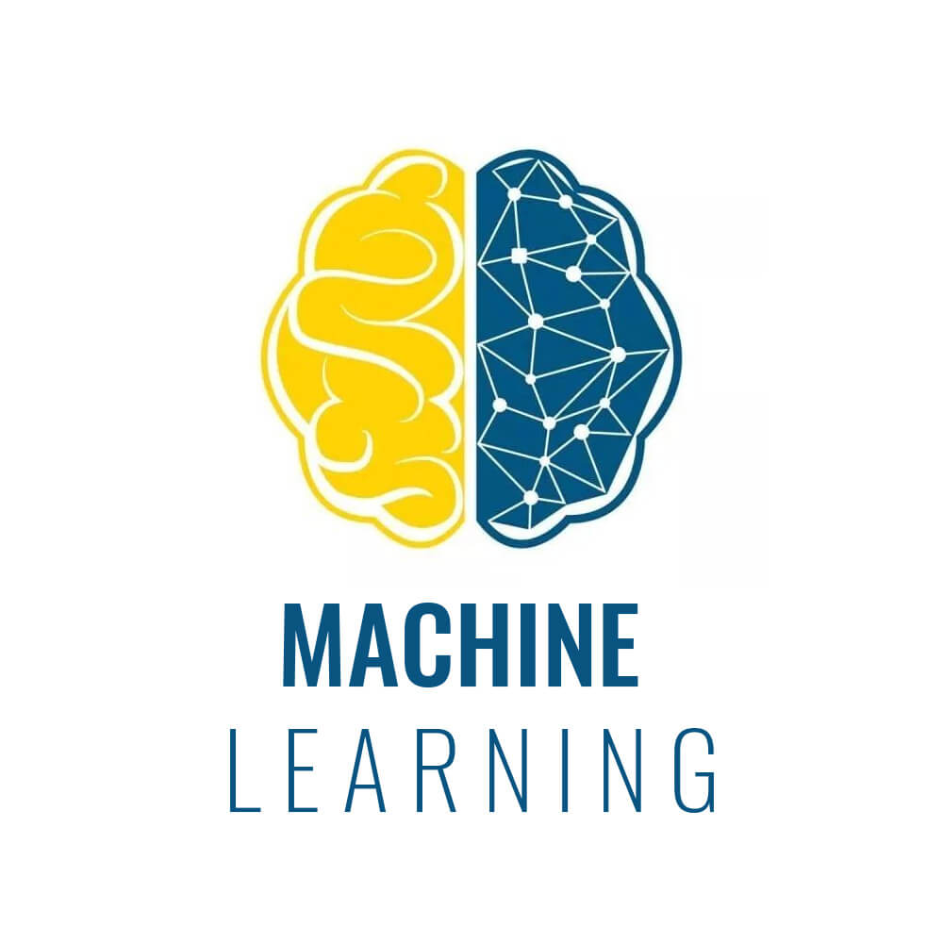

**Software and Hardware Requirement:**

**Software requirements:**

1. Operating System-Windows 10
2. Android Studio
3. Python3
4. HTML & CSS
5. MySQL Server
6. Amazon AWS
7. Code Editor

**Hardware requirements:**

1. Intel i7 processor/AMD A10 Processor or above
2. 4 GB Ram, 32 GB internal storage
3. Smart phone
4. Smart watch
5. Sensors, microprocessor



**Solution Brief description:**

To achieve the desired results based on the problem statement.

1. Create a mobile application to track the health of the employee from the wearable technology, update their health parameters in the cloud for every 30 seconds. Built the app using python language and design UI/UX to display the health parameters of the employee. Implement feature like user can manually add data like medical documents and view them whenever needed.
2. Create a web application to track, maintain all the employee’s health information using database. Store the employee details in the cloud, visualize their health information based on critical and normal values by prediction model in ML and alert the employee to take the necessary precautions needed beforehand.

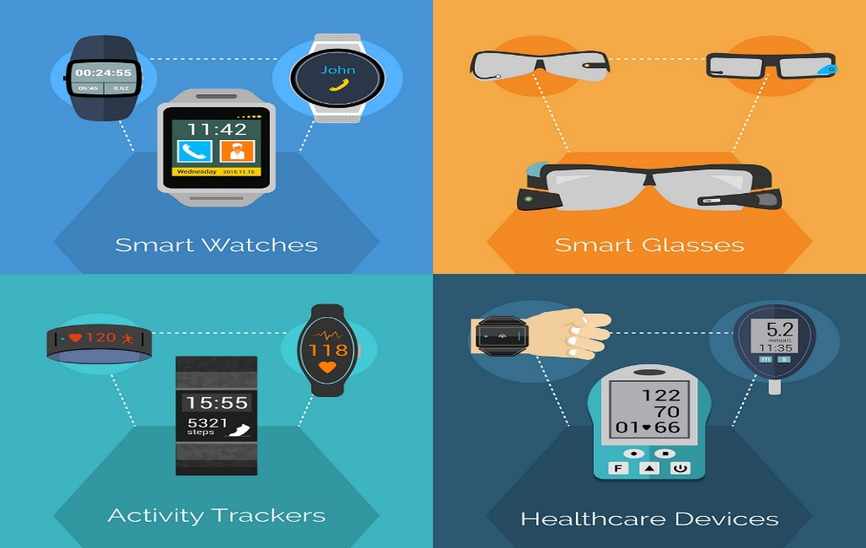



**ARCHITECTURE:**

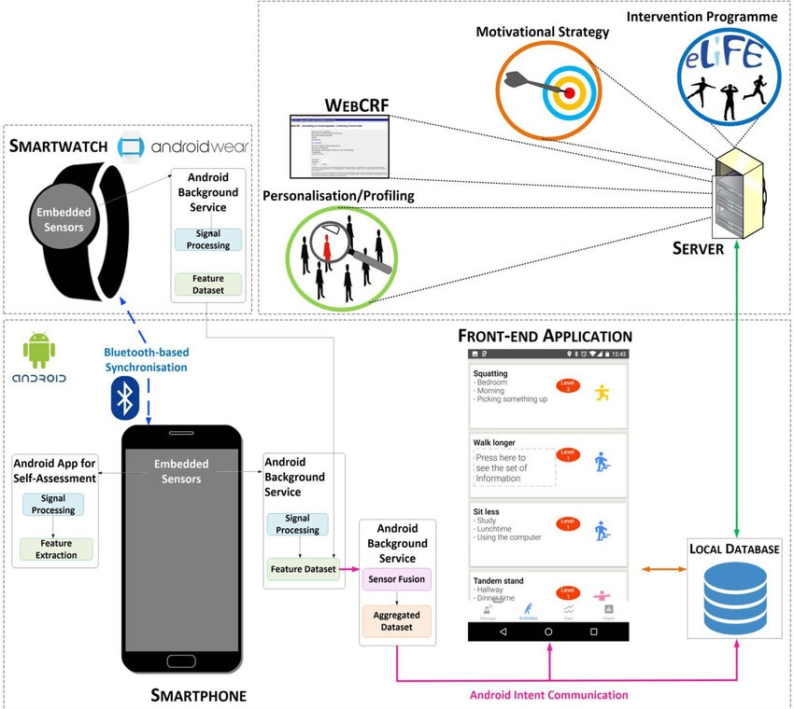

**OVERALL WORKFLOW:**

If any fluctuation happens the person is considered not as health conscious and precaution messages will be sent.



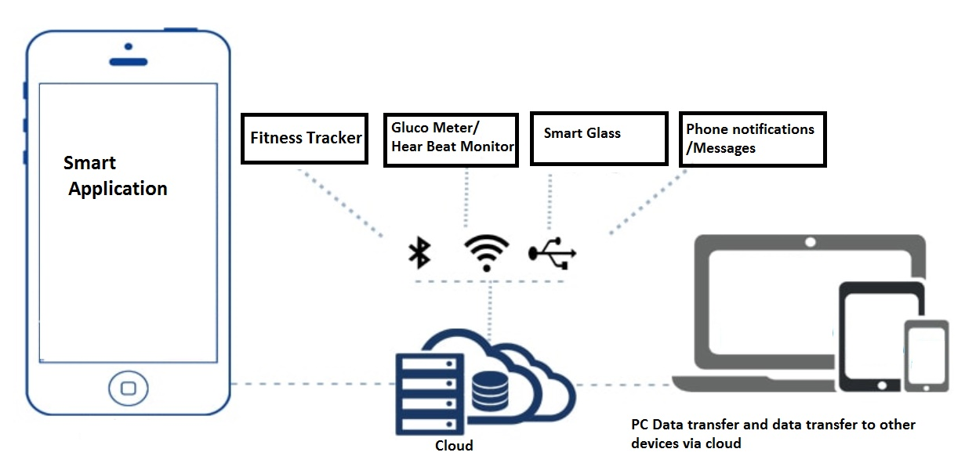

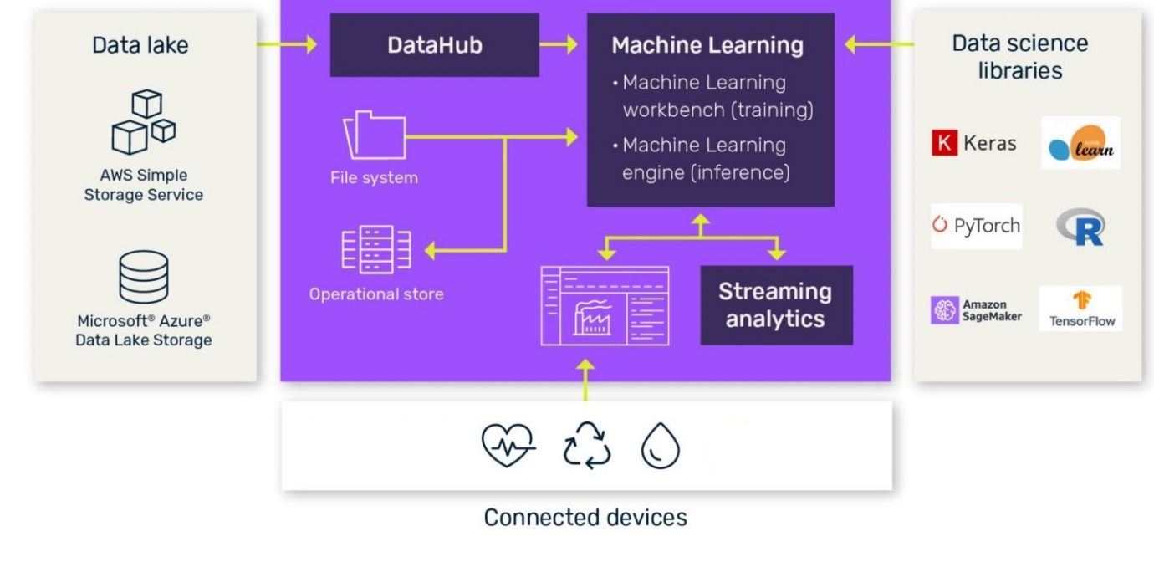



**TECHNICAL WORKFLOW:**

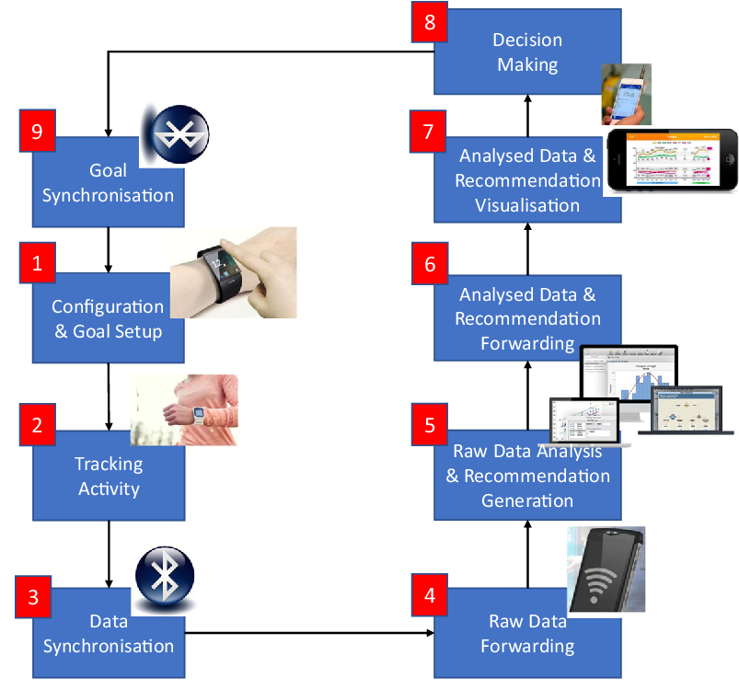

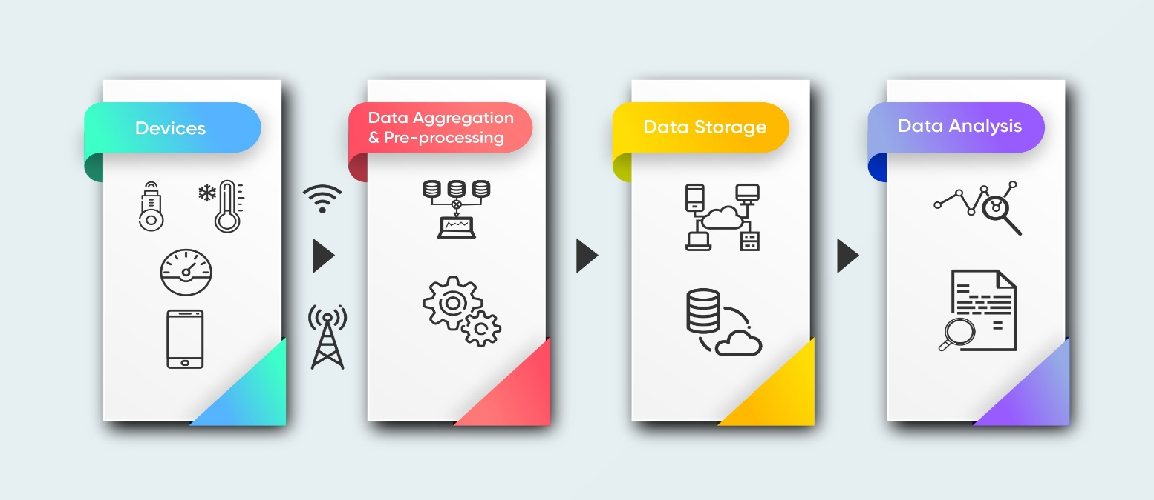



The heart beat is taken as the crucial parameter to evaluate. The prediction model is already trained using data sets to predict if the employee is healthy or not.

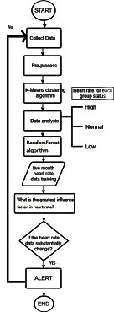

If not healthy, the employee will receive a message as “Not health conscious” and recommend necessary steps to stay on the other side of the line.



**APPLICATION INTERFACE:**

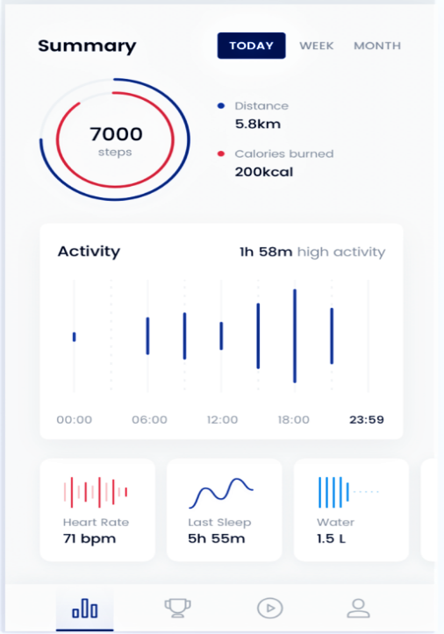

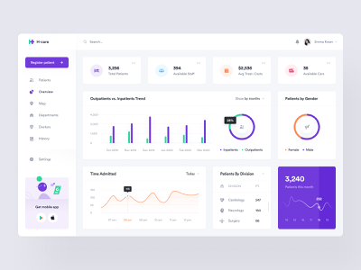

**PROS:**

1. Monitor healthcare of employee.
2. Helps them to avoid certain health issues.
3. Increases productivity.
4. Empower the employee-employer relationship.



**CONCLUSION:**

This IoT Model is refined for employee health care monitoring. I hope you really liked the solution. Make sure you watch the Video presentation the link is provided in the beginning of the document.



**THANK YOU FOR THIS OPPORTUNITY**